ITP project

**Online library “Innopolis Library”**

**Group**: BS1-1

**Supervisor**: Daniel De Carvalho

**Educational institution**: Innopolis University

**Team members**: Niaz Tuleulov, Anastasia Boiko, Artyom Ivanov

|  |  |
| --- | --- |
| **Contents** | |
| Section | page |
| 1.1 Problem: Why it is Relevant | 3 |
| 2 Description of the Project | 4 |
| 2.1 FrontEnd | 5 |
| 2.2 BackEnd | 6 |
|  |  |

Online Library – why it is relevant?

The digital library is an ordered collection of dissimilar electronic documents (including books), equipped with means of navigation and search.

The electronic library is a collection of documents in digital format, accessibility that depends on the availability of computer technology, respectively. Nowadays, it is possible to use a large number of electronic libraries by the global computer network.

The main goals of the digital library are:

1. informational, aimed to the needs of getting information of different categories of users across all the knowledge’s sectors or in one of the subject areas
2. educational,  which is realized through the high popularity of books, manuscripts and other documents relating to the history and culture;
3. Research-oriented, aimed on deep studyings of the subject by highly enlightened scientists and specialists, through the provision of the dissertations and handwritten materials
4. The reference, allowing to receive reliable information, reflected in documents of a specific type.

It can be stated with all certainty: electronic libraries are a fundamentally new, promising, perspective form of library existence in the information society, the main whose purpose is to improve the library service.

In addition, here is the statistics of the Kent State University of comparing an amount of people (in Ohio) who use printed documents to amount of people who take them from database in recent years.

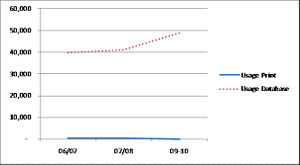

Description of Project: “Innopolis library”

1. **Roles of the team members**:

*Niaz Tuleulov*: Backend Development

Languages and resources: PHP, SQL, ORM System , MariaDB

*Anastasiya Boiko*: Frontend Development

Languages and resources: HTML, CSS, BootStrap, JavaScript

*Artyom Ivanov* : Documentation and Presentations

1. **Link to the website with our project**: <http://forsomeone.000webhostapp.com/>
2. **GitHub repository**: https://github.com/niazlake/Expo

# Technical issues

## Frontend

### HTML5

For the frontend we have chosen HTML5. Since the invention of the worldwide Internet, HTML became one of the most convenient markup tools for creating websites. The HTML language is constantly being improved, providing many new features, which make it possible to develop exclusive Internet projects.

There are several reasons for using HTML5:

1. New features of HTML5 make it possible to make the document code much cleaner than before
2. There is no need to use third-party programs such as “Adobe Flash” to work with photos or listen to the music
3. The data input in HTML 5 becomes simpler and more pleasant. This is expressed in the verification of information even before its publication, which is not inherited from the old version.

### CSS

However, to develop a modern website, it is not enough to use just a HTML. Therefore we used **Cascading Style Sheets** to design a website that can meet modern standards.

This allowed us to develop our library in “Innopolis Style”

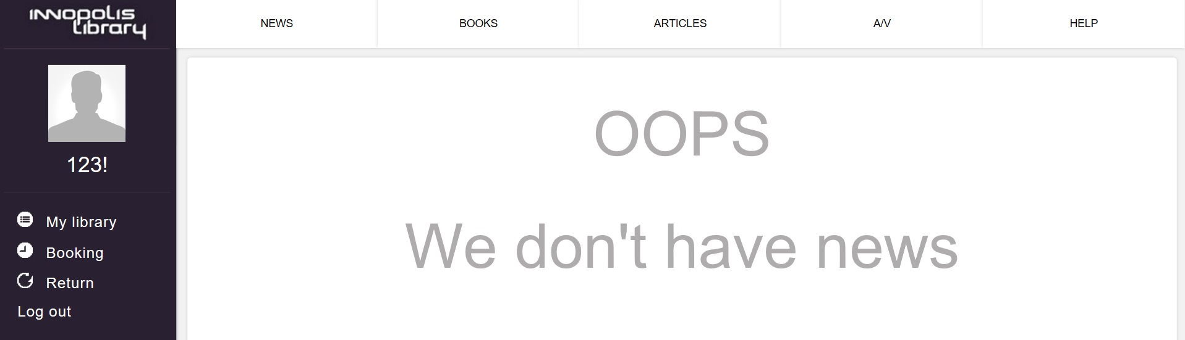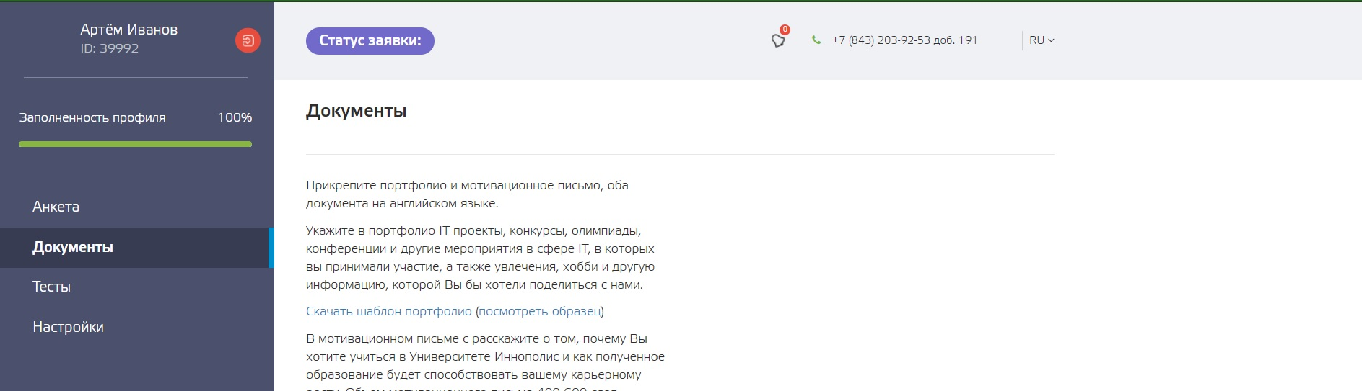

## Backend

We created our library and checked all the test cases using PHP. There are several reasons for such choice:

1. MySQL is used with PHP as back-end tool. MySQL is the popular online database and can be interfaced very well with PHP. Therefore, PHP and MySQL are excellent choice for webmasters looking to automate their web sites.
2. PHP language has its roots in C and C++. PHP syntax is most similar to C and C++ language syntax. So, programmers find it easy to learn and manipulate.
3. PHP can be used with a large number of relational database management systems, runs on all of the most popular web servers and is available for many different operating systems.
4. PHP5 a fully object oriented language and its platform independence and speed on Linux server helps to build large and complex web applications.

Here’s the example of a test case (more in the GitHub repository)

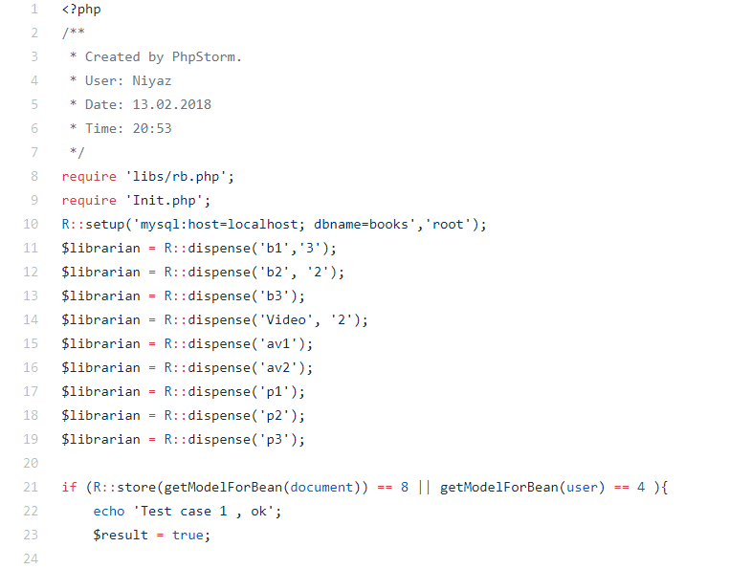

Let’s take a look at the code more attentively:

1. Login System

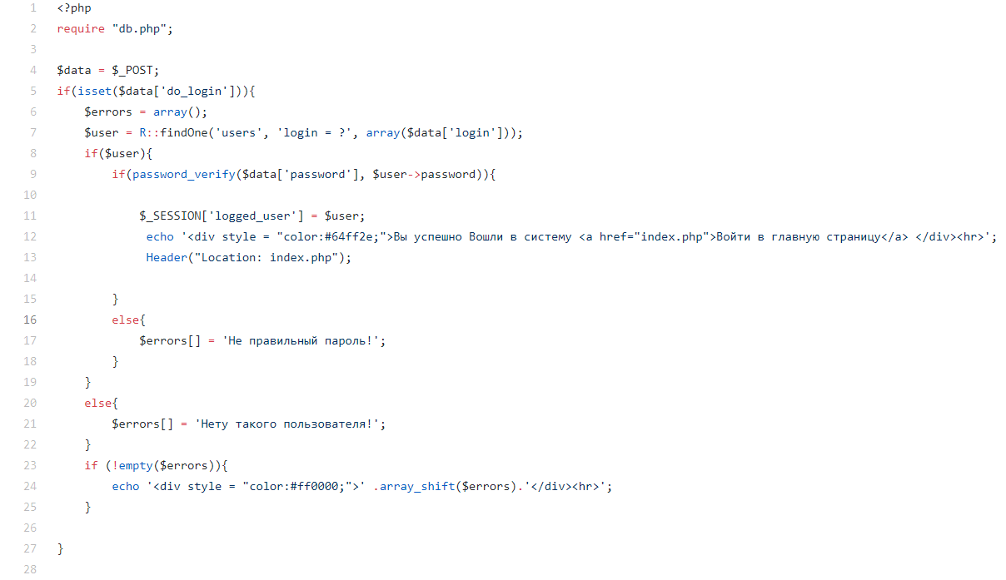

**What it does**:

Firstly, it send a request to a database and checks whether access is allowed (if database is no accessible, we will receive an exception). After that it takes data from two fields (login and password). If two forms are empty or such user with certain password does not exist, the exceptions would be raised. Else, the user will enter his account.

1. Registration

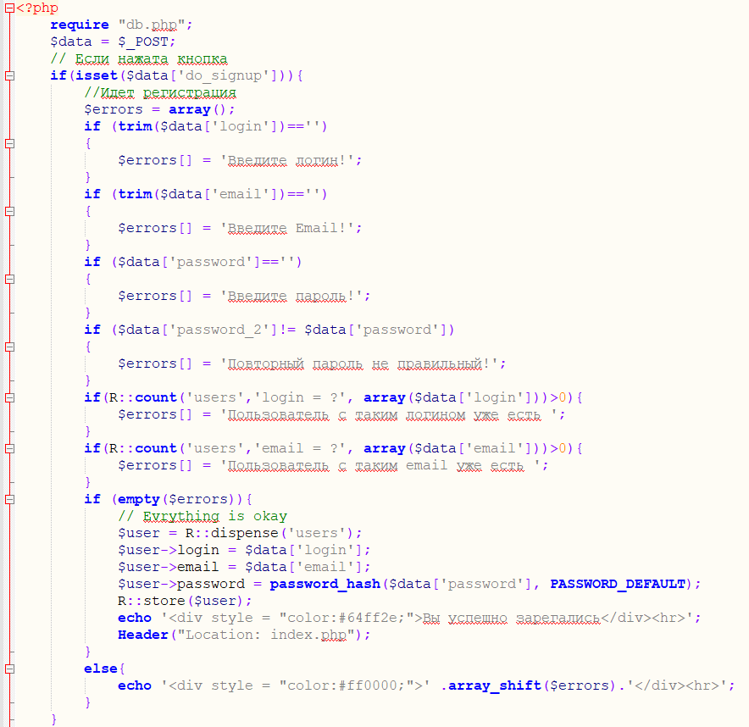

**What it does**: checks every form. If they are filled with data, then checks whether the account with such login or password already exists. After that, it puts all information into the database MariaDB

1. File “Expo/all”

This file contains all programs’ system and all the architecture. The main aim of this file is to manipulate the database (adding and editing information). It contains pretty big amount of classes and “set/get” functions in order to simplify the working process with SQL. Instead of writing the huge amount of code in SQL language, we designed special algorithms that allow us, for instance, only in two lines of code to create a table or add new users into a database.

1. Special Functions

public function getInsertID();  
**What it does:** this function allows us to get all the information about a certain client using his unique ID. It was designed for librarians to let them know, for instance, what book does this user obtain.

public function getDatabase();

**What it does**: it takes all data from database about users, books, A/V files, bestsellers, money and time periods. This function also simplifies the work with receiving data from database.

public function next();

**What it does:** this function is responsible for adding new users to our system. All new users will be added to the stack, so the librarians could approve or disapprove a certain request of new users to become a member of the system.

1. User’s Status

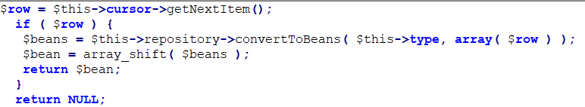

**What it does**: this function allows users with different priority to receive the books in the right order: Professors have higher priority in a priority queue; therefore they have more chances to get a copy of the book than students. Moreover, each user has its own rating and professors with high rating more likely will get a copy then professors with low rating.

That is how users get default ratings:

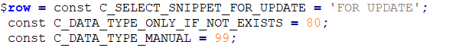

1. Update

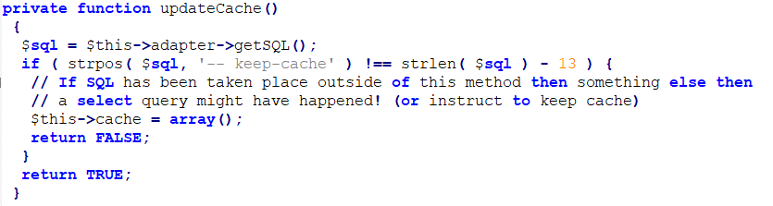

**What it does:** this function allows us to update a cache of a certain user, for example, to change his status and writes this data to a special array. It also checks whether there are any conflicts after updates.

1. Time

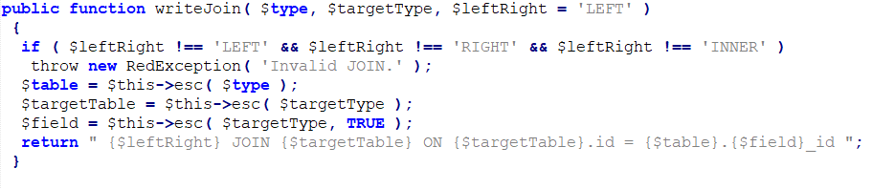

**What it does:** this function controls the time when the book was taken. Every day it subtracts a certain sum (in rubbles) from user’s bill if the user forgot to return the book to the library. If the penalty is bigger that a book’s price, than user will have to pay the price of the book.

1. Priority Class

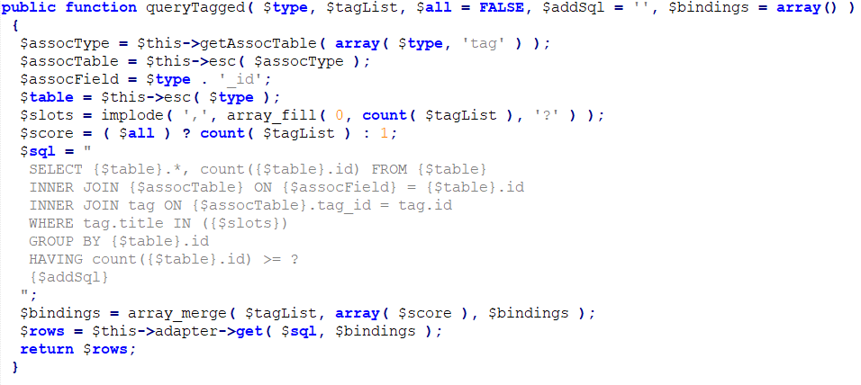

**What it does:** this class is responsible for creating a user with higher priority(TA or a Professor). Such user has its own rating (described in 5th paragraph) and he has an access to some books, which students cannot take.